CIS31041 - Practical for Data Mining

Lab Sheet 01
Question 01

The data set shown below the number of passengers flown by top five Airlines. Construct Bar Chart, Line Chart and Pie Chart to depict the following information.

Airlines | Delta | United | American | US Airways | Southwest
Passengers | 103,133 | 84,203 | 81,083 | 58,659 | 55,946

Construct Bar

Pie Chart

Line Chart

Year | Sales | Gross profit (Rs) | Net profit (Rs)
1974 | 100 | 30 | 10
1975 | 120 | 40 | 15
1976 | 140 | 45 | 35
1977 | 160 | 70 | 35
1978 | 170 | 75 | 40

Construct Bar Chart

Line Chart

Pie Chart

Question 02
Calculate Mean, Median, Mode, Quartiles, Inter Quartile Range (IQR)
- 36 , 48, 90, 67, 81, 41, 28, 34, 90, 77, 90

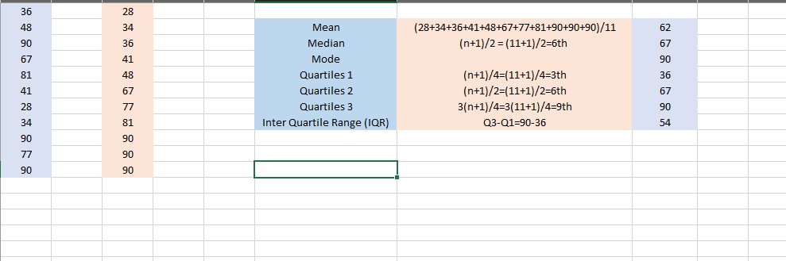

- 6 , 7 , 2 , 5 , 6 , 0 , 3 , 6, 7 , 4 , 5 , 4 , 5 , 7, 7

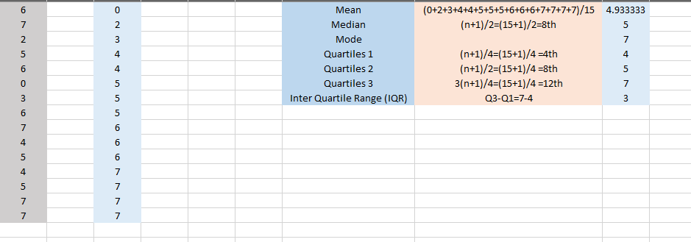

Question 03
- Estimate the following for the below grouped frequency distribution table
- Measures the mean, Var, Std, CV for the following data.

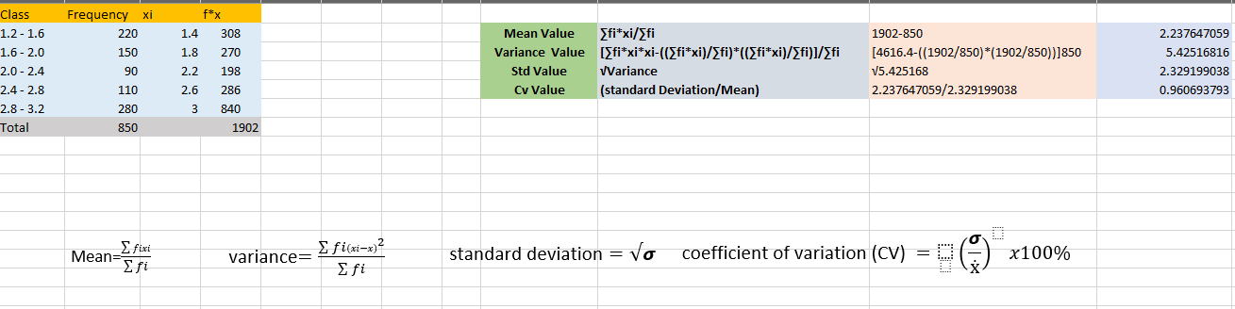
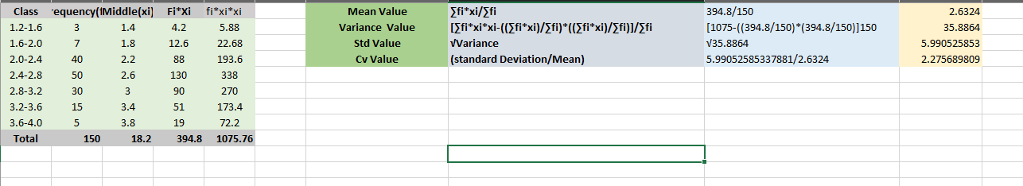

Question 04
Calculate the correlation coefficient of the following data set and find the linear regression model
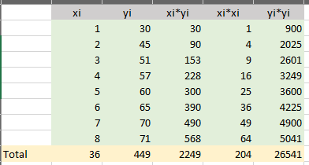
- (1,30), (2,45), (3,51), (4,57), (5,60), (6,65), (7,70), (8,71)

ii. (100,75), (120,90), (140,115), (160,140), (170,155)

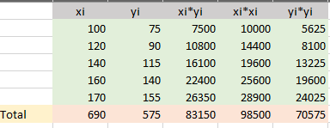

Exercises:
Construct Bar Chart, Line Chart and Pie Chart to depict the following information

Days | Number of Light |  | Power Bill
Day 1 | 10 | 100
Day 2 | 20 | 200
Day 3 | 30 | 300
Day 4 | 40 | 400
Day 5 | 50 | 500

Bar Chart

Line Chart

Pie Chart

Calculate Mean, Median, Mode, Quartiles, Inter Quartile Range (IQR)
- 8, 15, 18, 13, 15, 28, 30, 17, 41, 27, 17, 17, 44, 31, 24
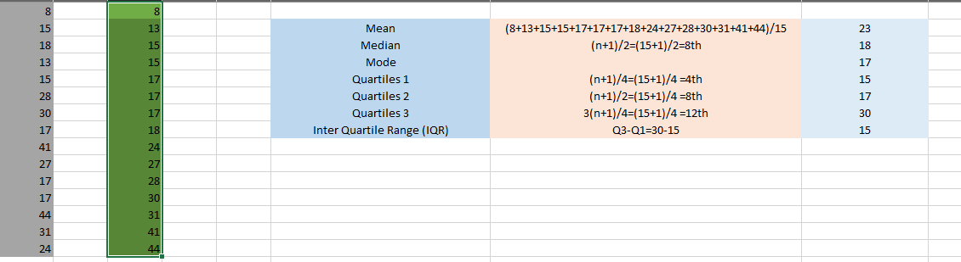

Calculate the correlation coefficient of the following data set and find the linear regression model

- (32,30), (36,30), (39,31), (40,39), (41,37), (41,34), (44,37), (45,41)

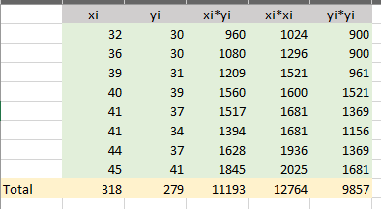

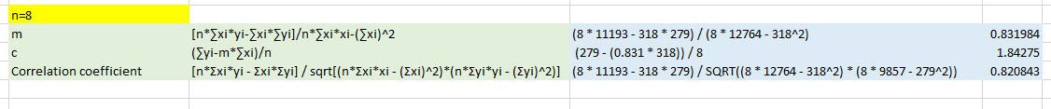

Discussion:

Lab Sheet 03
Title: Python for Data Mining
Aim:
- Work with Google Colab
Task:
- Getting practices with python
- Getting practices of colab
Exercises
- Basic mathematical operations using python
  - Addition
  - Subtraction
  - Multiplication
  - Division
  - Floor Division
  - Power

# Define two numbers
a = 15
b = 4

# i. Addition
addition = a + b
print("Addition:", addition)

# ii. Subtraction
subtraction = a - b
print("Subtraction:", subtraction)

# iii. Multiplication
multiplication = a * b
print("Multiplication:", multiplication)

# iv. Division
division = a / b
print("Division:", division)

# v. Floor Division
floor_division = a // b
print("Floor Division:", floor_division)

# vi. Power
power = a ** b
print("Power:", power)
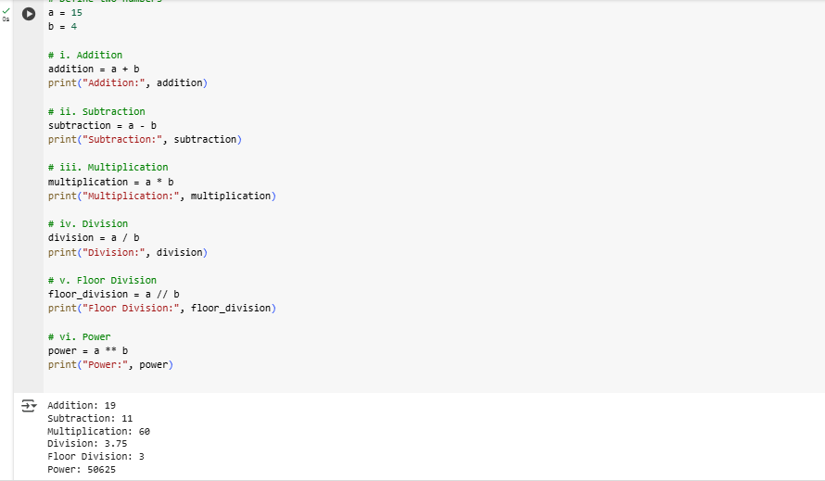

- Working of String array
  - Print the string array
  - Multiply the string array
  - Retrieve a character
  - Retrieve the set of character
  - Concatenate the string
  - Find the length of the string array

# Define a string array
string_array = ["Hello", "World", "Python"]

# i. Print the string array
print("String Array:", string_array)

# ii. Multiply the string array (repeat each string 2 times)
multiplied_array = [s * 2 for s in string_array]
print("Multiplied String Array:", multiplied_array)

# iii. Retrieve a character (e.g., first character of first string)
char = string_array[0][0]
print("First character of first string:", char)

# iv. Retrieve a set of characters (e.g., first 3 characters of second string)
subset = string_array[1][0:3]
print("First 3 characters of second string:", subset)

# v. Concatenate the string array into one string
concatenated_string = " ".join(string_array)
print("Concatenated String:", concatenated_string)

# vi. Find the length of the string array (number of elements)
array_length = len(string_array)
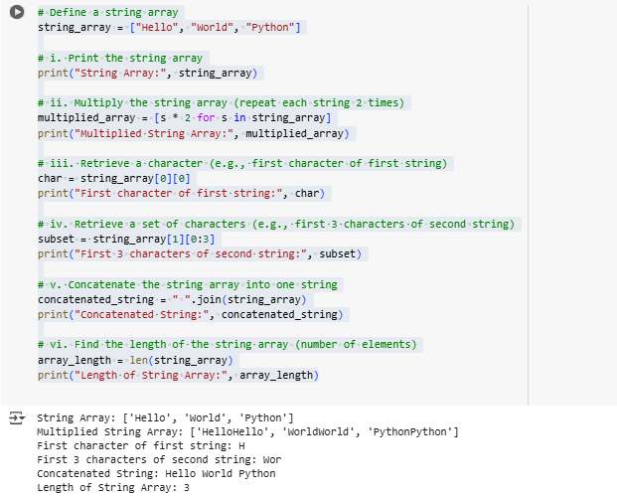
print("Length of String Array:", array_length)

- List
  - Introduction to list
  - Assigning value for index
  - Assigning multiple values
  - Length of list
  - Append the element
  - Remove the element
  - Copy the list

# i. Introduction to list
my_list = [10, 20, 30, 40]
print("Initial List:", my_list)

# ii. Assigning value for index (change value at index 2)
my_list[2] = 35
print("After assigning value at index 2:", my_list)

# iii. Assigning multiple values (replacing a slice)
my_list[1:3] = [25, 45]
print("After assigning multiple values:", my_list)

# iv. Length of list
length = len(my_list)
print("Length of the list:", length)

# v. Append the element
my_list.append(50)
print("After appending 50:", my_list)

# vi. Remove the element
my_list.remove(25)
print("After removing 25:", my_list)

# vii. Copy the list
copied_list = my_list.copy()
print("Copied List:", copied_list)

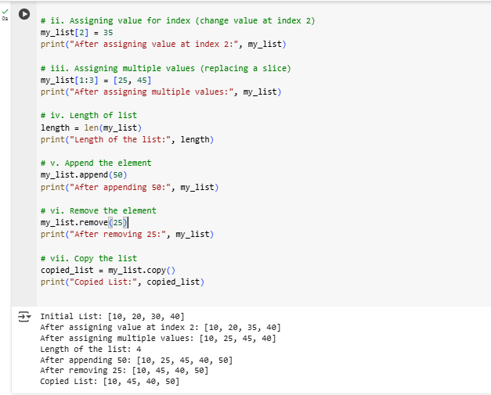

- Control flow structure
  - If -elif-else
  - While
  - For
  - Continue
  - Break

# i. if - elif - else
num = 15
if num > 20:
print("Number is greater than 20")
elif num == 20:
print("Number is equal to 20")
else:
print("Number is less than 20")

# ii. while loop
print("\nWhile Loop:")
count = 0
while count < 3:
print("Count is:", count)
count += 1

# iii. for loop
print("\nFor Loop:")
for i in range(5):
print("i =", i)

# iv. continue
print("\nContinue Statement:")
for i in range(5):
if i == 2:
continue # Skip the iteration when i == 2
print("i =", i)

# v. break
print("\nBreak Statement:")
for i in range(5):
if i == 3:
break # Exit the loop when i == 3
print("i =", i)
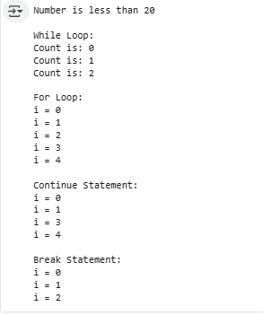

- Basic Function in python

# Function without parameters
def greet():
print("Hello! Welcome to Python.")

# Function with parameters
def add(a, b):
return a + b

# Function with default parameter
def welcome(name="Guest"):
print(f"Welcome, {name}!")

# Function with return statement
def square(x):
return x * x

# Calling the functions
greet() # No parameters
result = add(10, 5) # With parameters
print("Addition Result:", result)

welcome("Alice") # With argument
welcome() # Using default

squared = square(6) # Using return value
print("Square of 6 is:", squared)

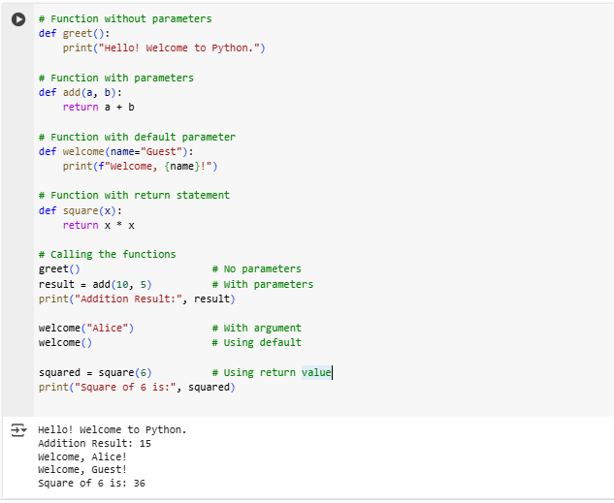

- Stack (Last In First Out (LIFO))
  - Create the stack
  - Append the stack
  - Remove the element in stack

# i. Create the stack
stack = []
print("Initial Stack:", stack)

# ii. Append to the stack (push operation)
stack.append(10)
stack.append(20)
stack.append(30)
print("Stack after pushing elements:", stack)

# iii. Remove the element from the stack (pop operation)
removed_element = stack.pop()
print("Removed Element:", removed_element)
print("Stack after popping element:", stack)

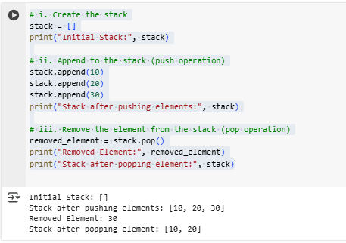

- Queue (First In First Out ( FIFO))

  - Create the queue
  - Insert the element in queue
  - Remove the element in queue

from collections import deque

# i. Create the queue
queue = deque()
print("Initial Queue:", queue)

# ii. Insert the element in queue (enqueue)
queue.append("A")
queue.append("B")
queue.append("C")
print("Queue after enqueuing elements:", queue)

# iii. Remove the element in queue (dequeue)
removed_element = queue.popleft()
print("Removed Element:", removed_element)
print("Queue after dequeuing element:", queue)

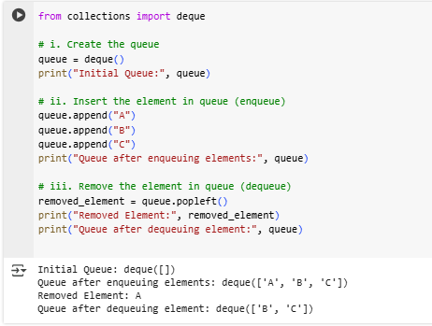

Lab Sheet 04
Aim:
  - Working with Matrix
  - Working with tuples
  - Working with class
Task:
- Matrix Implementation
  - Create the matrix
  - Transform the matrix

# Creating a matrix
matrix = [
[1, 2, 3],
[4, 5, 6],
[7, 8, 9]
]

print("Original Matrix:")
for row in matrix:
print(row)

# Transforming the matrix (Transpose)
transposed_matrix = [[matrix[j][i] for j in range(len(matrix))] for i in range(len(matrix[0]))]

print("\nTransposed Matrix:")
for row in transposed_matrix:
print(row)

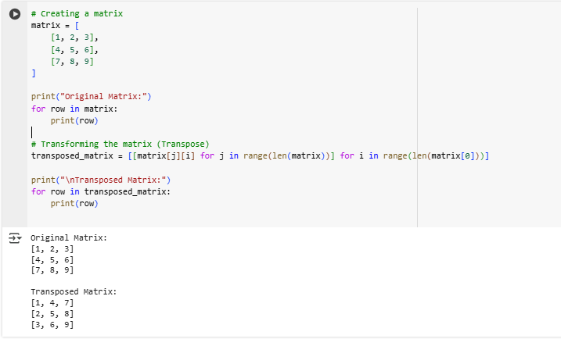
- Tuples Implementation
  - Creating a tuples
  - Create two tuples and merge together.
  - Print the elements in tuples

# a. Creating a tuple
tuple1 = (1, 2, 3, 4, 5)
print("Tuple1:", tuple1)

# b. Create two tuples and merge them together
tuple2 = ('a', 'b', 'c')
merged_tuple = tuple1 + tuple2
print("Merged Tuple:", merged_tuple)

# c. Print the elements in the tuple
print("Elements in Merged Tuple:")
for element in merged_tuple:
print(element)

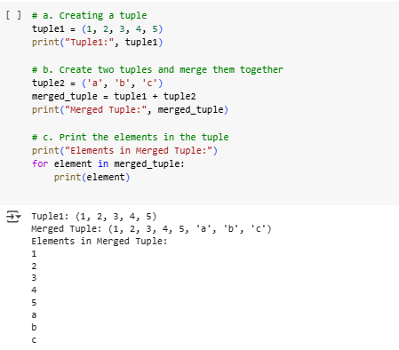

- Array
  - Defining an array
  - print the array
  - Print the last element

# a. Defining an array
array = [10, 20, 30, 40, 50]

# b. Print the array
print("Array:", array)

# c. Print the last element
print("Last element of the array:", array[-1])
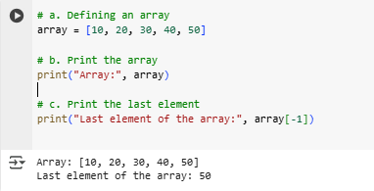

- Date functions
  - Today date
  - Birthday

import datetime

# a. Today's date
today_date = datetime.date.today()
print("Today's Date:", today_date)

# b. Birthday (Example)
birthday = datetime.date(2000, 5, 15) # Change to your actual birthday
print("Example Birthday:", birthday)

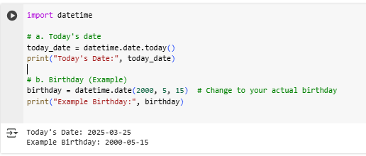

- Numpy
  - Import the numpy array as np
  - Concatenate of two arrays
  - Create the empty array
  - Creates an array of consecutive integers starting from 0 up to specified value.
  - Create the two-dimensional array
  - Sort the array
  - Find the shape, size, dimension of array
  - Reshape the array
  - Increase the dimension of array
  - Indexing and slicing
  - Create the array from existing data
  - Reshape the existing element
  - Print the array in vertical and horizontal stack
  - Split the array
  - Basic array operations
  - Summary of the array
  - Multiply the element in the array
  - Find the maximum and minimum element in the array
  - Transpose of the element

import numpy as np
print("Import NumPy as np (already done)\n")

# a. Import NumPy as np (already done)

print("a.Import NumPy as np (already done)\n")
# b. Concatenation of two arrays
arr1 = np.array([1, 2, 3])
arr2 = np.array([4, 5, 6])
concatenated_arr = np.concatenate((arr1, arr2))
print("Concatenated Array:", concatenated_arr)
print("\n")

print("c. Create an empty array\n")
# c. Create an empty array
empty_array = np.empty((2, 2))
print("Empty Array:\n", empty_array)
print("\n")

print("d. Create an array of consecutive integers starting from 0\n")
# d. Create an array of consecutive integers starting from 0
consecutive_arr = np.arange(10)
print("Array of Consecutive Integers:", consecutive_arr)
print("\n")

print("e. Create a two-dimensional array\n")
# e. Create a two-dimensional array
two_d_array = np.array([[1, 2, 3], [4, 5, 6]])
print("2D Array:\n", two_d_array)
print("\n")

print("f. Sort the array\n")
# f. Sort the array
unsorted_arr = np.array([3, 1, 4, 1, 5, 9])
sorted_arr = np.sort(unsorted_arr)
print("Sorted Array:", sorted_arr)
print("\n")

print("g. Find shape, size, dimension\n")
# g. Find shape, size, dimension
print("Shape:", two_d_array.shape)
print("Size:", two_d_array.size)
print("Dimension:", two_d_array.ndim)
print("\n")

print("h. Reshape the array\n")
# h. Reshape the array
reshaped_arr = np.reshape(consecutive_arr, (2, 5))
print("Reshaped Array:\n", reshaped_arr)
print("\n")

print("i. Increase dimension of the array\n")
# i. Increase dimension of the array
expanded_arr = np.expand_dims(arr1, axis=0)
print("Increased Dimension Shape:", expanded_arr.shape)
print("\n")

print("j. Indexing and slicing\n")
# j. Indexing and slicing
print("First element of arr1:", arr1[0])
print("Slice of arr1:", arr1[1:])
print("\n")

print("k. Create an array from existing data\n")
# k. Create an array from existing data
copied_arr = np.copy(arr1)
print("Copied Array:", copied_arr)
print("\n")

print("l. Reshape the existing array\n")
# l. Reshape the existing array
reshaped_existing = np.reshape(arr1, (3, 1))
print("Reshaped Existing Array:\n", reshaped_existing)
print("\n")

print("m. Print the array in vertical and horizontal stack\n")
# m. Print the array in vertical and horizontal stack
vstacked = np.vstack((arr1, arr2))
hstacked = np.hstack((arr1, arr2))
print("Vertical Stack:\n", vstacked)
print("Horizontal Stack:", hstacked)
print("\n")

print("n. Split the array\n")
# n. Split the array
split_arr = np.array_split(concatenated_arr, 2)
print("Split Arrays:", split_arr)
print("\n")

print("o. Basic array operations\n")
# o. Basic array operations
sum_arr = arr1 + arr2
diff_arr = arr1 - arr2
prod_arr = arr1 * arr2
print("Sum:", sum_arr)
print("Difference:", diff_arr)
print("Product:", prod_arr)
print("\n")

print("p. Summary of the array\n")
# p. Summary of the array
print("Mean:", np.mean(arr1))
print("Standard Deviation:", np.std(arr1))
print("\n")

print("q. Multiply elements in array\n")
# q. Multiply elements in array
multiplied_arr = arr1 * 2
print("Multiplied Array:", multiplied_arr)
print("\n")

print("r. Find max and min elements\n")
# r. Find max and min elements
print("Max:", np.max(arr1))
print("Min:", np.min(arr1))
print("\n")

print("s. Transpose of a 2D array\n")
# s. Transpose of a 2D array
transposed_two_d = np.transpose(two_d_array)
print("Transposed 2D Array:\n", transposed_two_d)
print("\n")

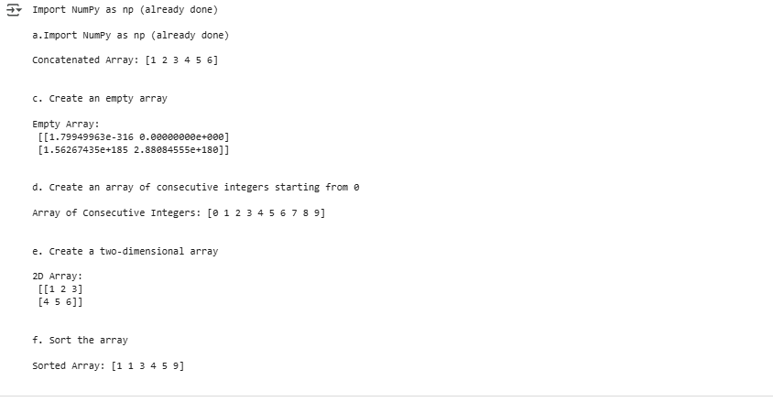

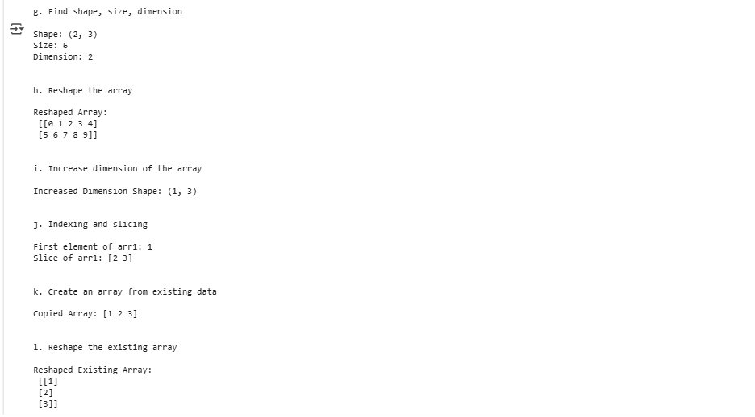

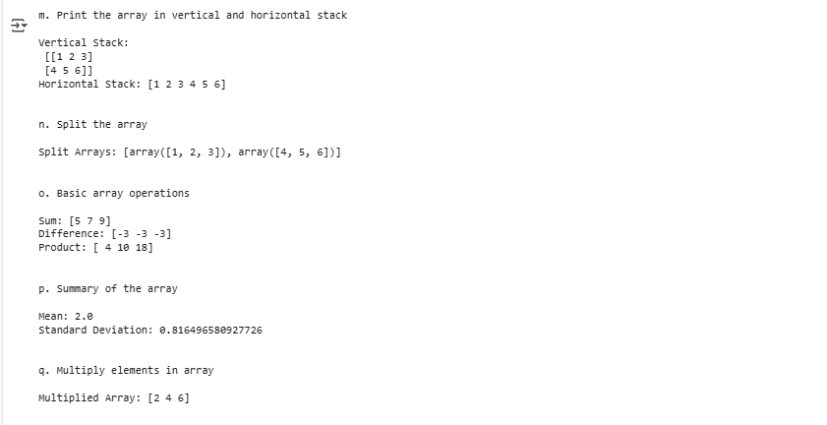

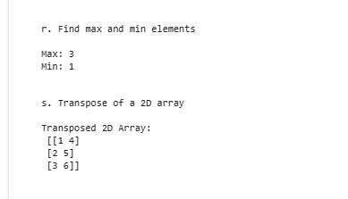

Lab Sheet 04

